Real Time Clock

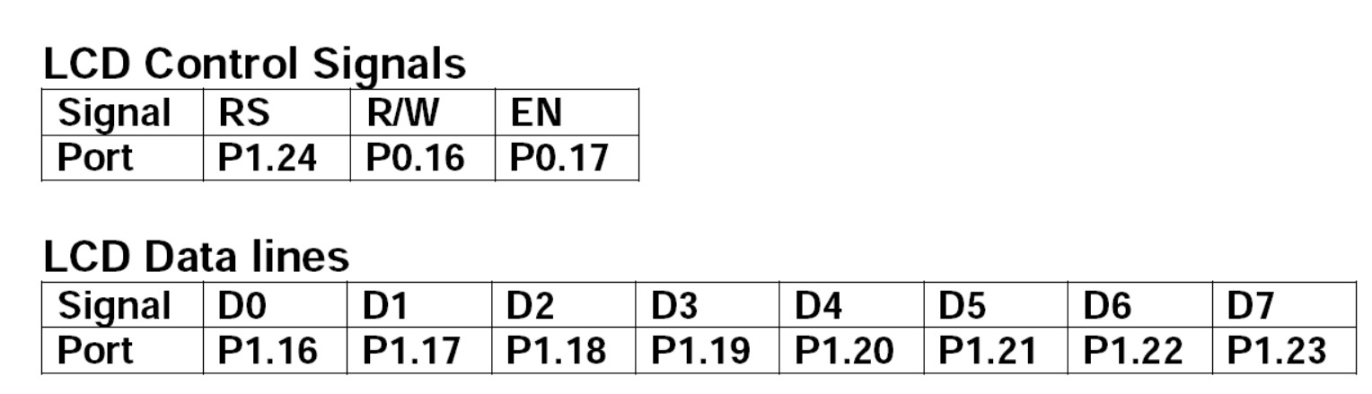

#include <lpc214x.h> // Include the header file for LPC2148

// Define control pins based on the new configuration

#define RS (1 << 24) // P1.24 for RS

#define RW (1 << 16) // P0.16 for R/W

#define EN (1 << 17) // P0.17 for EN

// Define data pins based on the new configuration

#define DATA_MASK (0xFF << 16) // P1.16 - P1.23 for data lines (D0-D7)

void delay(unsigned int count) {

while (count--) {

for (volatile int i = 0; i < 3000; i++); // Simple delay loop

}

}

void lcd_command(unsigned char command) {

IOCLR1 = DATA_MASK; // Clear data lines

IOSET1 = (command << 16); // Send command to data lines (P1.16 - P1.23)

IOCLR1 = RS; // RS = 0 for command mode

IOCLR0 = RW; // RW = 0 for write mode

IOSET0 = EN; // EN = 1

delay(2);

IOCLR0 = EN; // EN = 0

}

void lcd_data(unsigned char data) {

IOCLR1 = DATA_MASK; // Clear data lines

IOSET1 = (data << 16); // Send data to data lines (P1.16 - P1.23)

IOSET1 = RS; // RS = 1 for data mode

IOCLR0 = RW; // RW = 0 for write mode

IOSET0 = EN; // EN = 1

delay(2);

IOCLR0 = EN; // EN = 0

}

void lcd_init(void) {

// Configure control pins as output

IODIR0 |= RW | EN;

IODIR1 |= RS;

// Configure data pins as output

IODIR1 |= DATA_MASK;

lcd_command(0x38); // 8-bit mode, 2-line display, 5x7 font

lcd_command(0x0C); // Display ON, cursor OFF

lcd_command(0x06); // Auto increment cursor

lcd_command(0x01); // Clear display

delay(5);

}

void lcd_set_cursor(unsigned char line, unsigned char position) {

unsigned char address;

if (line == 1)

address = 0x80 + position; // Line 1 starts at 0x80

else if (line == 2)

address = 0xC0 + position; // Line 2 starts at 0xC0

lcd_command(address); // Set DDRAM address

}

void lcd_display_string(char *str) {

while (*str) {

lcd_data(*str++);

}

}

int main(void) {

lcd_init(); // Initialize LCD

lcd_set_cursor(1, 0); // Set cursor to Line 1, Position 0

lcd_display_string("WELCOME TO"); // Display "WELCOME TO" on Line 1

lcd_set_cursor(2, 0); // Set cursor to Line 2, Position 0

lcd_display_string("EMBEDDED SYSTEMS"); // Display "EMBEDDED SYSTEMS" on Line 2

while (1); // Infinite loop to keep the program running

}

OUTPUT:

